
College of Technology and Built Environment
School of Information Technology and Engineering
Year three, Semester One; School of Software Engineering
Fasika Farmers’ Connect
Fundamentals of software engineering: Prepare a Software Requirements Specification Documentation.

Prepared by Section1 Group 6 students:
- Seada Hassen: UGR/8927/16
- Eleni Demlie: UGR/ 7940 /16
- Betelehem meheret: UGR/ 2245/ 16
- Nathnael Belay: UGR/9296/16
- Leulekal walelign: UGR/0922/16
- Abreham Yonatan: UGR/4463/16
- Kidist Nega: UGR/1923/16
- Yeabsera Zewdu: UGR/1970/16
- Haimanot Beka: UGR/0869/13

Due Date: 18/12/2025

Table of Contents
List of Tables iii
List of figures iv
Definitions, Acronyms, Abbreviations iv
1. Introduction 1
1.1 Purpose 1
1.2 General Overview 1
1.2.1 System Context and Organization 1
1.2.2 Architecture Overview and Design Goals 1
1.3 Development Methods & Contingencies 2
1.3.1 System and Software Design Approach 2
1.3.2 Design Method Justification and Alternatives 2
1.3.3 Contingencies and Mitigation Plan 2
2. System Architecture 3
2.1 Subsystem decomposition 3
2.1 Subsystem Decomposition 3
2.2 Hardware/software mapping 4
3. Object Model 5
3.1 Class Diagram 5
3.2 Sequence Diagram 5
3.2 State chart Diagram (optional element) 15
4. Detailed Design 17
Detailed Design - Entity Classes Tables 17
User Class 17
Attributes Table 17
Operations Table 18
Farmer Class 18
Attributes Table 19
Operations Table 19
Buyer Class 19
Attributes Table 20
Operations Table 20
Admin Class 20
Operations 21
PRODUCELISTING CLASS 21
Table 21
Attributes 22
Operations 22
FARMINGTIP CLASS 22
Attributes 23
Operations 23
MARKETPRICE CLASS 24
Attributes 24
Operations 25
DASHBOARD CLASS 25
Attributes 25
Operations 26
Detailed Design – Tables of each Boundary Classes 26
Detailed Design Control Classes & References 33

List of Tables
Table1:Detailed Design - Entity Classes Tables 17
Table2:User Class 17
Table3:Attributes Table 17
Table4:Operations Table 18
Table5:Farmer Class 18
Table6:Attributes Table 19
Table7:Operations Table 19
Table8:Buyer Class 19
Table9:Attributes Table 20
Table10:Operations Table 20
Table11:Admin Class 20
Table12:Operations 21
Table13:PRODUCELISTING CLASS 21
Table14:Attributes 21
Table15:Operations 22
Table16:FARMINGTIP CLASS 22
Table17:Attributes 23
Table18:Operations 23
Table19:MARKETPRICE CLASS 24
Table20:Attributes 24
Table21:Operations 25
Table22:DASHBOARD CLASS 25
Table23:Attributes 25
Table24:Operations 26
Table25:Detailed Design – Tables of each Boundary Classes 26
Table26:Detailed Design Control Classes 33

List of figures
Figure1:UC01RegistrationSequenceDiagram..................................................6 Figure2:UC02LoginSequentialDiagram...........................................................7 Figure3:UC03SearchSequentialDiagram.........................................................8 Figure4:UC04ApplicationSequenceDiagram...................................................9 Figure5:UC05PersonalizedReccommendationSD...........................................10 Figure6:UC06FeedbackSystemSD...................................................................11 Figure7:UC07ProfileManagementSD..............................................................12 Figure8:UC08ApplicationReviewSD................................................................13 Figure9:UC09AccessResourceSequenceDiagram...........................................14

Definitions, Acronyms, Abbreviations

Term | Definition
AgriConnect | The agricultural e-commerce platform connecting farmers directly with buyers
Farmer | A registered user who posts agricultural produce for sale on the platform
Buyer | A registered user who browses and purchases agricultural produce
Admin | System administrator with privileges to manage users, content, and platform settings
Produce Listing | A product posting by a farmer containing details of agricultural produce for sale
Farming Tip | Educational content providing agricultural advice and best practices
Market Price | Current commodity pricing data for various agricultural products
Dashboard | Personalized summary screen displaying user-specific activities and statistics
Entity Class | Represents persistent data stored in the database
Boundary Class | Represents user interface screens and forms
Control Class | Manages business logic and coordinates between entity and boundary classes
UML | Unified Modeling Language - standardized modeling language for software systems
SDS | Software Design Specification - detailed design document
Authentication | Process of verifying user identity
Authorization | Process of determining user access privileges
Session | Temporary interactive information exchange between user and system
API | Application Programming Interface - set of rules for software communication
REST | Representational State Transfer - architectural style for web services
JSON | JavaScript Object Notation - lightweight data interchange format

Acronym | Full Form | Description
UML | Unified Modeling Language | Standard visual modeling language
SDS | Software Design Specification | Detailed design document
API | Application Programming Interface | Interface for software components to communicate
REST | Representational State Transfer | Web service architectural style
JSON | JavaScript Object Notation | Data interchange format
JWT | JSON Web Token | Token-based authentication standard
HTTP | HyperText Transfer Protocol | Application protocol for distributed information systems
HTTPS | HTTP Secure | Secure version of HTTP
UI | User Interface | Space where interactions between humans and machines occur
UX | User Experience | User's overall experience with a product or service
DB | Database | Organized collection of structured data
SQL | Structured Query Language | Language for managing relational databases
CRUD | Create, Read, Update, Delete | Basic operations of persistent storage
MVC | Model-View-Controller | Software design pattern
CSS | Cascading Style Sheets | Style sheet language for describing presentation
HTML | HyperText Markup Language | Standard markup language for documents
JS | JavaScript | Programming language for web interactivity
npm | Node Package Manager | Package manager for JavaScript
IDE | Integrated Development Environment | Software for building applications
OS | Operating System | System software that manages hardware and software
RAM | Random Access Memory | Computer's short-term memory
CPU | Central Processing Unit | Primary component of a computer
SSD | Solid State Drive | Data storage device
GB | Gigabyte | Unit of digital information
MB | Megabyte | Unit of digital information
KB | Kilobyte | Unit of digital information
IP | Internet Protocol | Communications protocol

Acronym | Full Form | Description
WAF | Web Application Firewall | Filters and monitors HTTP traffic
CDN | Content Delivery Network | Network of servers delivering content
CI/CD | Continuous Integration/Continuous Deployment | Software development practice
SDK | Software Development Kit | Set of software development tools
IoT | Internet of Things | Network of physical objects with sensors
GPS | Global Positioning System | Satellite-based navigation system
SMS | Short Message Service | Text messaging service
MFA | Multi-Factor Authentication | Authentication using multiple verification methods

Introduction

1.1 Purpose
The purpose of this System Design Specification (SDS) document is to provide a detailed technical design for the Fasika Farmers Connect Platform.
This document translates the business requirements and agricultural processes, as outlined in the Software Requirements Specification (SRS), into a concrete technical framework that guides the development of the system. Specifically, it details the architecture, system components, database structures, and interface considerations necessary to connect farmers with markets, resources, and expert knowledge efficiently.
This SDS serves as the authoritative technical blueprint for developers, stakeholders, and project managers, ensuring the platform is implemented to meet both the essential functional requirements (e.g., crop data management, market pricing alerts) and the critical non-functional requirements (e.g., high availability in rural areas, security, and scalability) while adhering to agricultural technology best practices and standards.

General Overview

1.2.1 System Context and Organization
The Fasika Farmers Connect Platform is a critical national initiative designed to optimize the agricultural value chain. Its primary context is to serve as a digital marketplace and information hub, directly connecting smallholder farmers with buyers, essential input suppliers, and agricultural advisory services. This eliminates information asymmetry and reduces dependence on intermediaries, ensuring fairer pricing for producers.
The system is organized around a foundational 3-Tier Architecture, which promotes separation of concerns, simplifies maintenance, and enhances security. This classical structure divides the system into distinct Presentation, Application, and Data layers, allowing each layer to be optimized for its specific function.

1.2.2 Architecture Overview and Design Goals
The System Architecture is cloud-hosted and utilizes a highly available deployment model. The architecture strictly adheres to the 3-Tier Software Architecture pattern:
- Presentation Tier: Includes the client-facing interfaces (Mobile Application for farmers, Web Portal for buyers/administrators). This tier manages user input and displays data.
- Application (Business Logic) Tier: This central tier houses the core business logic, including the Marketplace Engine, User Authentication, and Data Processing. It ensures that data is correctly validated and processed according to business rules before interacting with the Data Tier.
- Data Tier: Comprises the centralized database management system (DBMS) that securely stores all persistent data, including user profiles, transaction logs, crop data, and market prices.
The primary Design Goals for the Fasika Farmers Connect Platform are:
- Reliability and Accessibility: To maintain high uptime and offer low-bandwidth-friendly interfaces (including potential SMS/USSD capability) to maximize adoption and ensure service delivery, regardless of geographic network constraints.
- Maintainability: The clear separation of the 3-Tiers allows for isolated updates and maintenance of the application logic without disrupting the data or presentation layers.
- Scalability: To allow for horizontal scaling of the Application and Presentation Tiers independently, accommodating projected national growth in the farmer user base and rapid transaction volume expansion.

1.3 Development Methods & Contingencies

1.3.1 System and Software Design Approach
The system and software design for the Fasika Farmers Connect Platform are being executed using an Agile/Scrum methodology. This iterative approach allows for frequent stakeholder feedback (especially from farmer cooperatives and agricultural experts) and rapid response to emerging design requirements.
The specific design techniques utilized are:
- Design Method: Object-Oriented Design (OOD) principles are applied to define the classes and relationships within the Application (Business Logic) Tier, promoting code reusability and maintainability within the 3-Tier framework.
- Modeling: UML (Unified Modeling Language) diagrams are the standard for documenting key functional components. Specifically, use case diagrams (for process flows) and component diagrams (to illustrate the structure of the three tiers and service integration) are employed.
- Architectural Pattern: The implementation of the 3-Tier Architecture is strictly followed to enforce separation of concerns, with specific attention paid to implementing secure and stateless communication between the Presentation and Application Tiers.

1.3.2 Design Method Justification and Alternatives
The Agile/Scrum framework was selected over a traditional Waterfall approach to allow for continuous deployment of features and early user testing, which is crucial for a new platform serving a diverse user group like farmers. Prototyping will be heavily used for the mobile application's interface to ensure high usability.
A pure J2EE monolithic approach was considered for stability but rejected in favor of leveraging modern cloud services to meet the extreme scalability and high availability goals required for national deployment.

1.3.3 Contingencies and Mitigation Plan
Several challenges may arise during the design and development process. Potential contingencies and their mitigation plans include
1,
- Contingency/Risk:
Unstable or Inconsistent Connectivity in Target Rural Deployment Areas
- Potential Impact:
Negative user experience, high data synchronization failure rates, and low platform adoption.
- Mitigation Strategy
Prioritize development of offline-first capabilities within the Mobile Application (Presentation Tier). This involves local data caching, transaction queuing, and background synchronization to ensure core functions (e.g., viewing market prices, logging crop inventory) remain usable without a continuous internet connection.
2,
- Contingency/Risk:
Unforeseen Agricultural Policy Changes
- Potential Impact:
Business logic (Application Tier) related to subsidy qualifications or market regulations may become instantly obsolete, requiring a major system rewrite.
- Mitigation Strategy
Implement a Rules Engine component within the Application Tier. This moves volatile policy and business rules out of the core code and into a configuration layer, allowing administrators to update policies without requiring a full system deployment.

System Architecture

2.1 Subsystem decomposition

2.1 Subsystem Decomposition
This section describes the high-level and detailed decomposition of the Fasika Farmers’ Connect Platform using UML Component Diagrams.
The system follows a 3-Tier Architecture, and the decomposition is presented in three levels, from abstract to detailed.
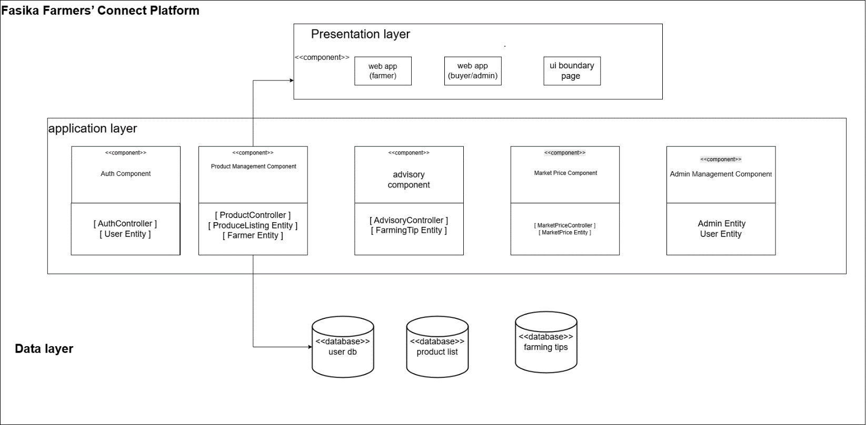

2.2 Hardware/software mapping
This section describes how the software components of the Fasika Farmers’ Connect Platform are deployed onto physical hardware nodes using a UML Deployment Diagram.
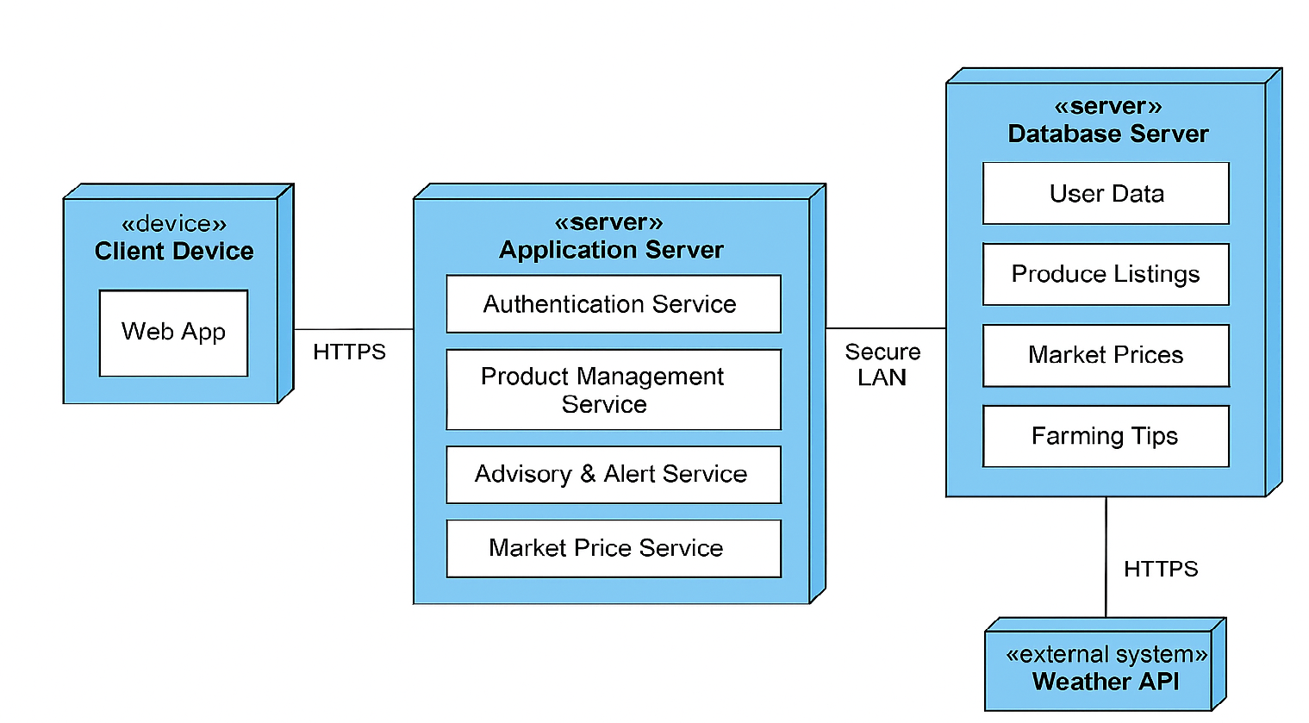

3. Object Model

3.1 Class Diagram

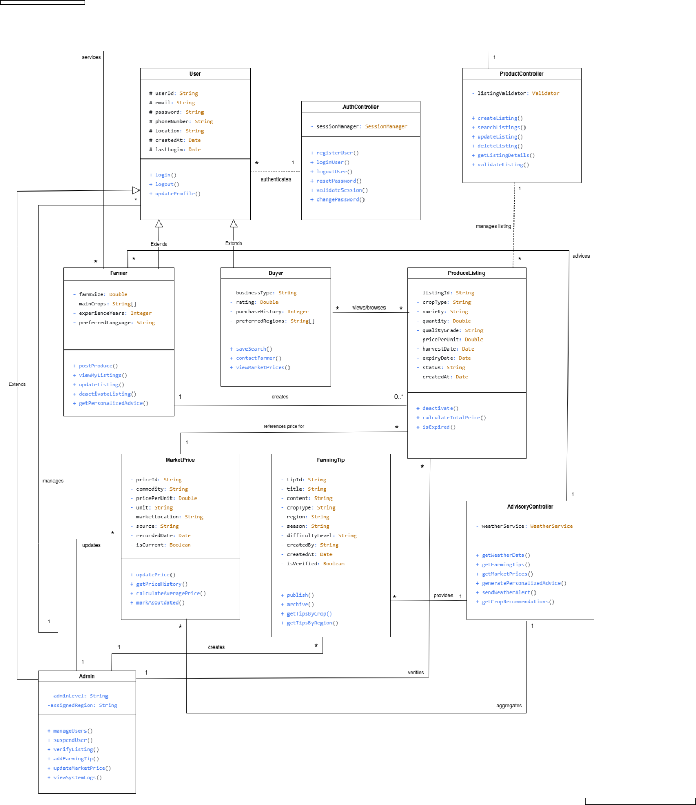

3.2 Sequence Diagram

UC01: Registration Sequence Diagram (RegistrationPage → AuthController → User)

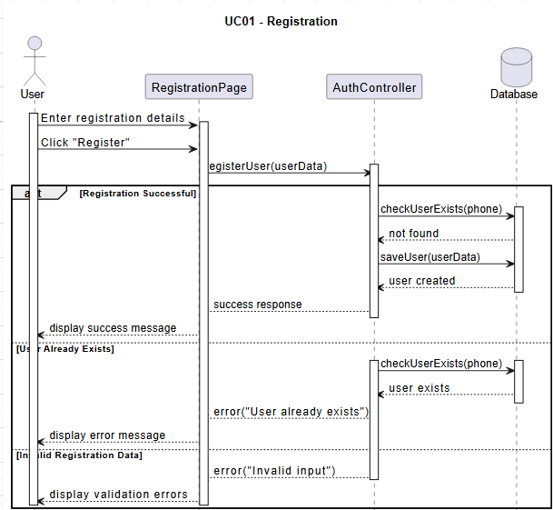

UC02: Login Sequence Diagram (LoginPage → AuthController → User)

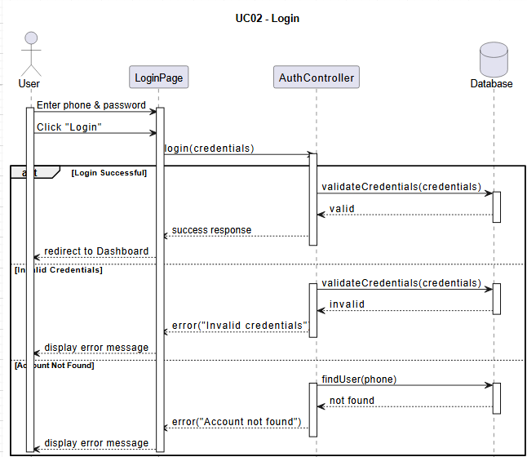

UC03: View Market Prices (DashboardPage → AdvisoryController → MarketPrice)

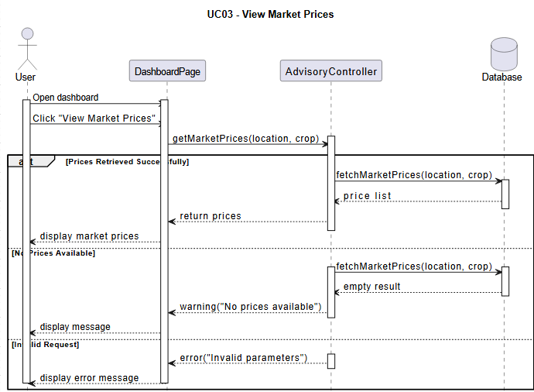

UC-04: View Farming Tips
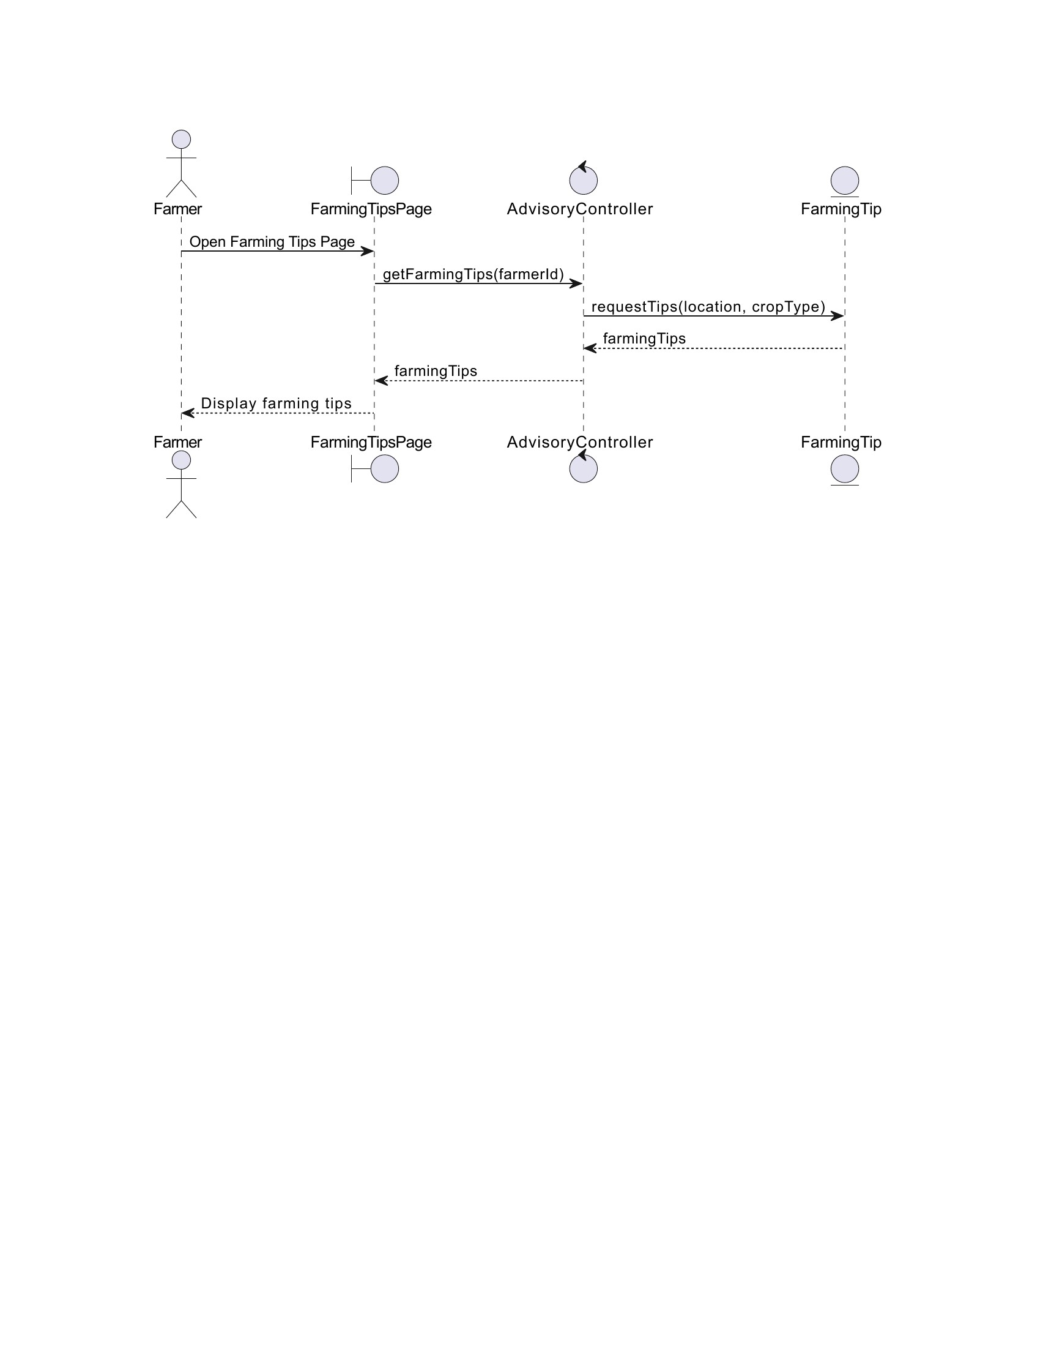
Primary Actor: Farmer
Components: FarmingTipsPage, AdvisoryController, FarmingTip
The farmer requests farming tips through the Farming Tips Page. The request is handled by the AdvisoryController, which retrieves relevant tips from the FarmingTip component based on location and crop type. The tips are then displayed to the farmer.

UC-05: Post Produce Listing
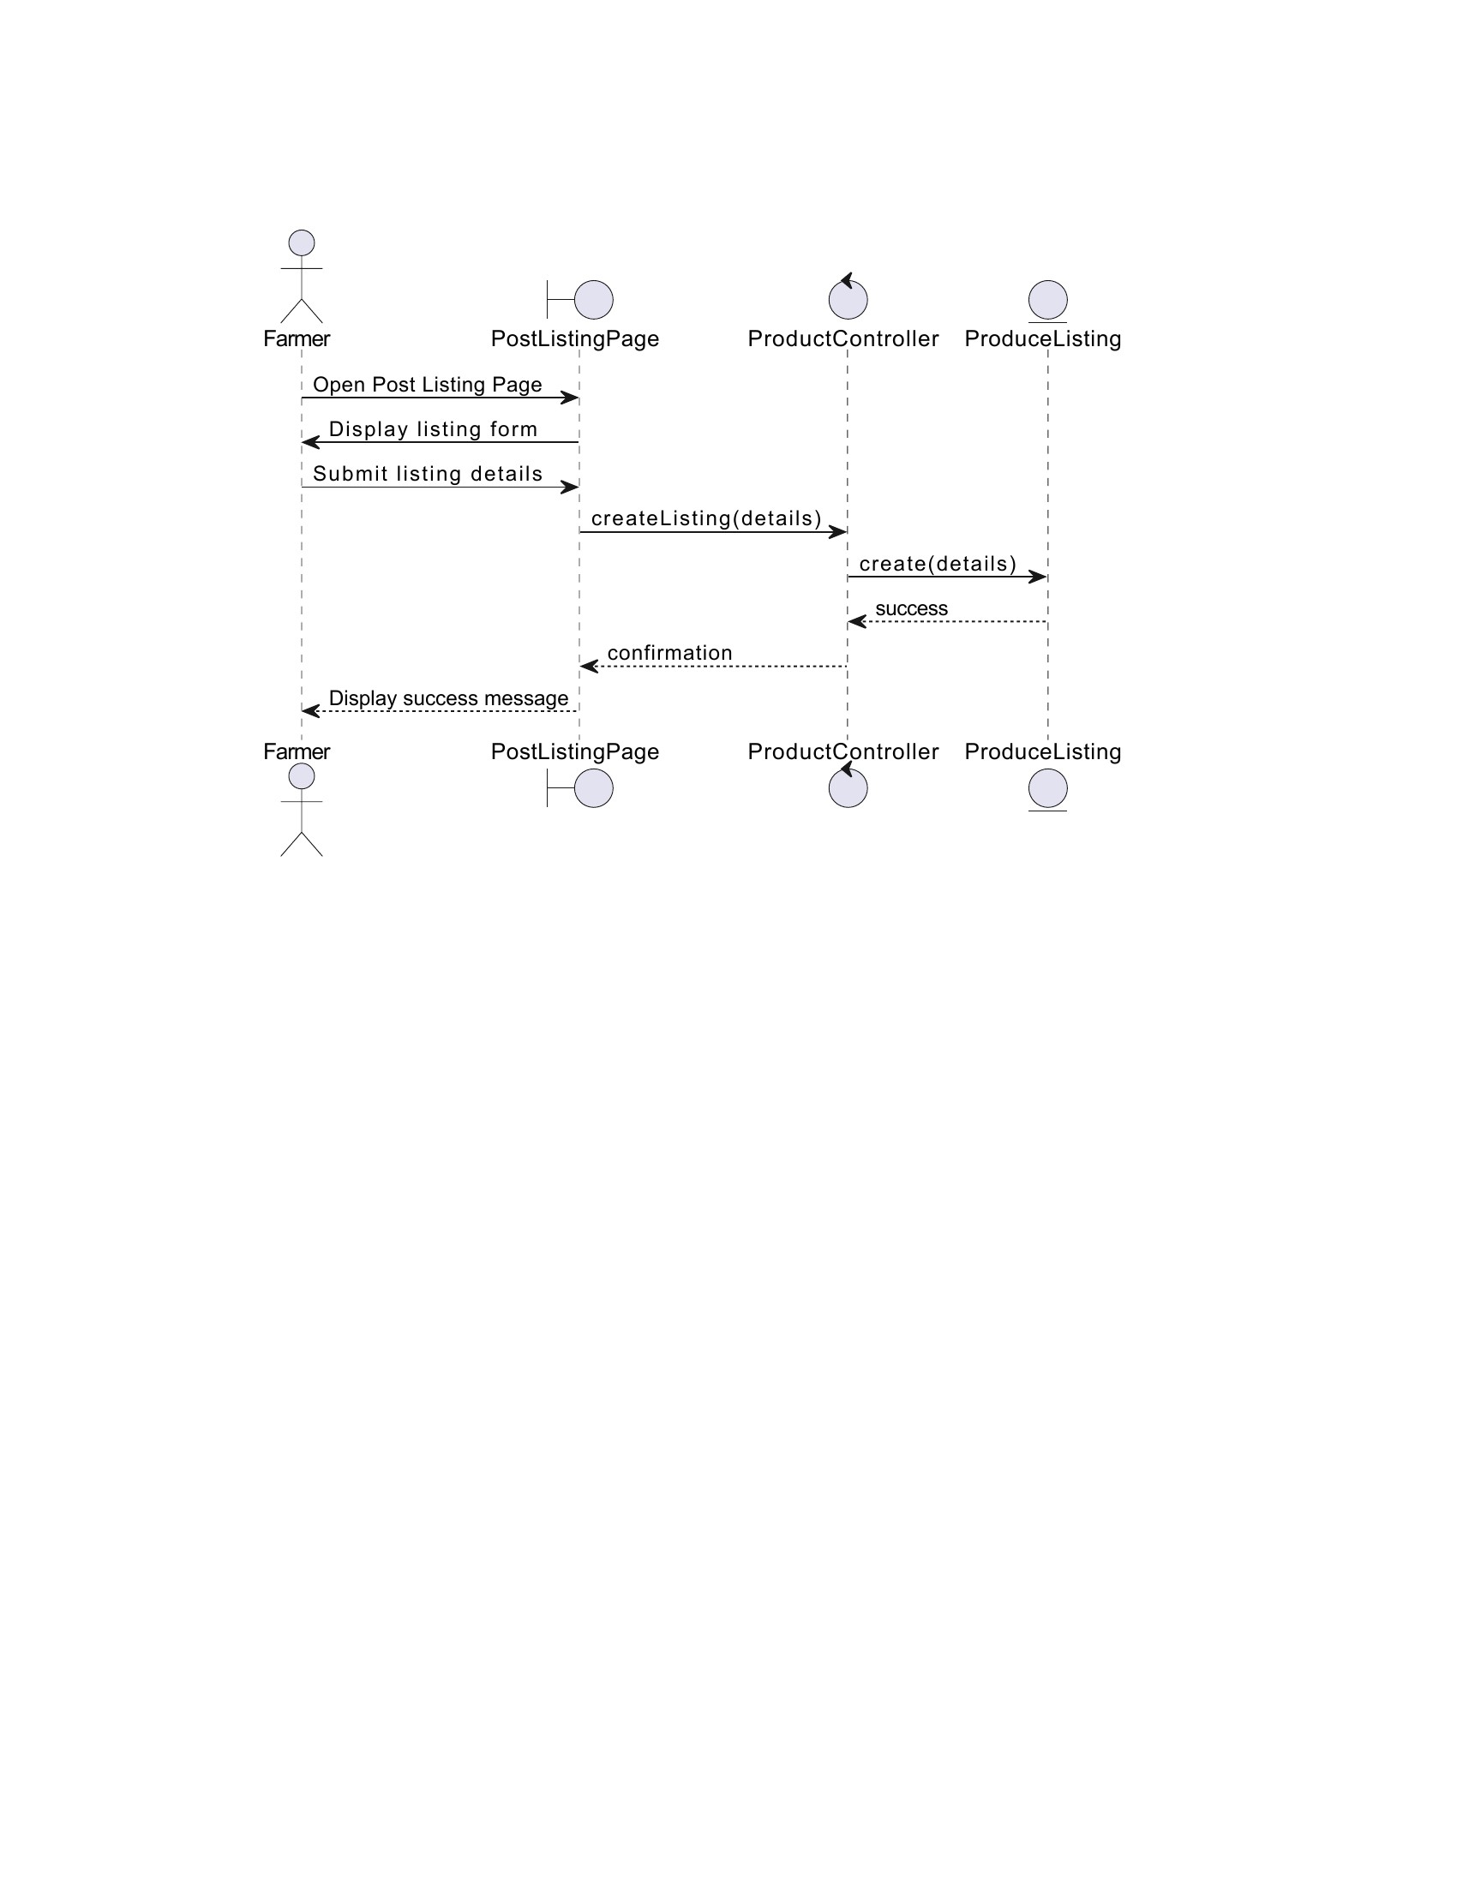

UC-06: Browse/Search Listings
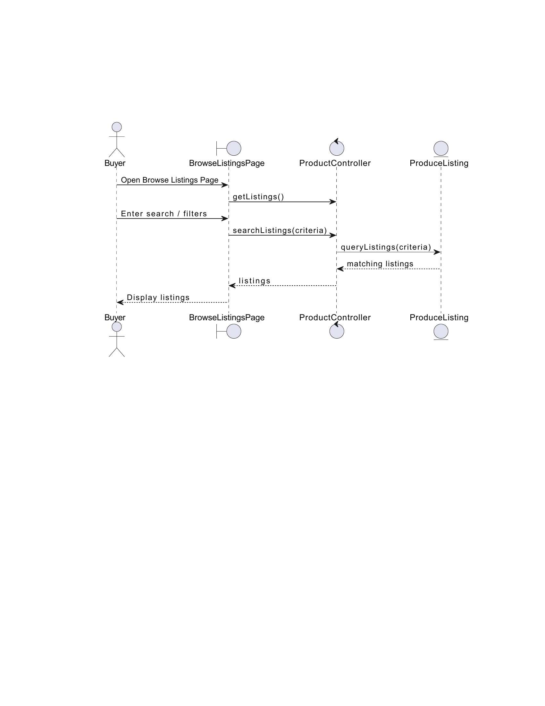

UC-7: VIEW CONTACT INFO

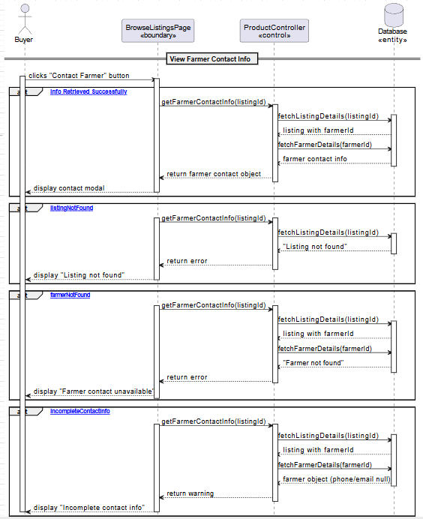

UC-8: UPDATE PROFILE

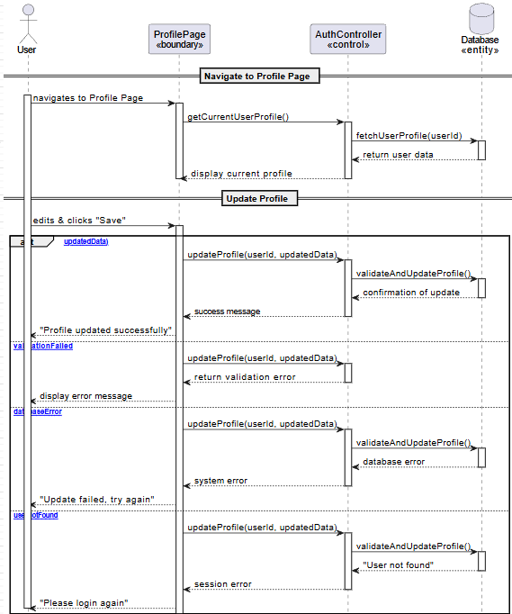

UC-9: ADMIN MANAGEMENT

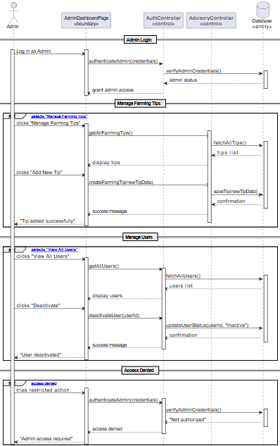

3.2 State chart Diagram (optional element)
STATE CHART-1:
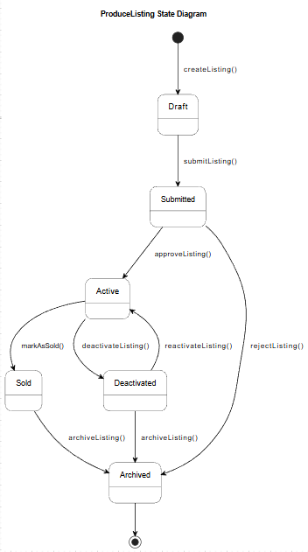

STATE CHART-2:
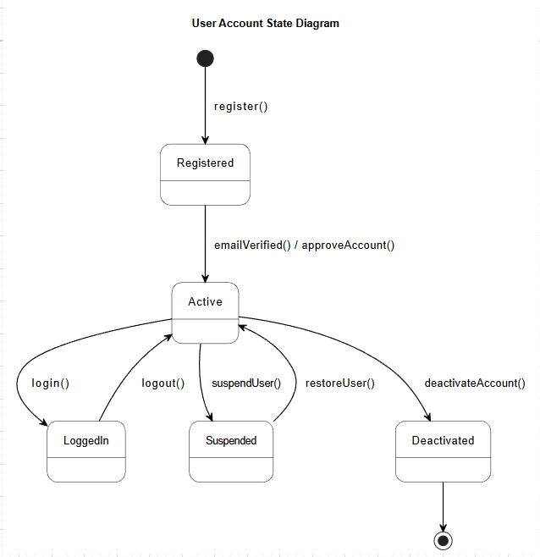

4. Detailed Design

Detailed Design - Entity Classes Tables

User Class
User Class
- userId: String
+ name: String
+ email: String
+ phone: String
+ passwordHash: String
+ role: String // farmer | buyer | admin
+ location: String
+ createdAt: DateTime

Attributes Table
Attribute | Type | Visibility | Invariant
userId | String | Private | Unique, not NULL
name | String | Public | Not NULL
email | String | Public | Valid email
phone | String | Public | Valid phone
passwordHash | String | Private | Encrypted
role | String | Public | farmer/buyer/admin
location | String | Public | Cannot be empty
createdAt | DateTime | Private | Auto-generated

Operations Table

Operation | Visibility | Return | Arguments | Pre-conditin | Post-conditio
register() | Public | Boolean | name,email,phone,password,role | Email unused | User created
login() | Public | Boolean | email,password | User exists | Session active
updateProfile() | Public | void | name,phone,location | Authenticated | Account Updated
deleteAccount() | Public | void | userId | Admin only | Account Removed

Farmer Class

Farmer Class
- farmerId: String
+ farmSize: Float
+ cropType: String
+ userId: String(FK)

Attributes Table
Attribute | Type | Visibility | Invariant
farmerId | String | Private | Unique
farmSize | Float | Public | ≥0
cropType | String | Public | Optional
userId | String | Private | Must corresponds to Exists User

Operations Table

Operation | Visibility | Return | Arguments | Pre | Post
updateFarmInfo() | Public | void | farmSize,cropType | Farmer logged in | Updated
viewListings() | Public | List | None | Farmer authenticated | Shown
postProduce() | Public | String | listingData | Farmer  Authenticated | Created

Buyer Class

Buyer Class
- buyerId: String
+ companyName: String
+ userId: String (FK)

Attributes Table
Attribute | Type | Visibility | Invariant
buyerId | String | Private | Unique
companyName | String | Public | Optional
userId | String | Private | Exists in User

Operations Table

Operation | Visibility | Return | Arguments | Pre condition | Post-condition
searchListings() | Public | List | filters | Buyer Logged in | Matching string Returned
viewListingDetails() | Public | Object | listingId | Buyer Authenticated | Details Shown

Admin Class
Admin Class
- adminId: String
+ userId: String (FK)

Attribute | Type | Visibility | Invariant
adminId | String | Private | Unique
userId | String | Private | Must map to a User with role = admin

Operations
Operation | Visibility | Return | Args | Pre | Post
approveUser() | Public | void | userId | Admin authenticated | User approved
deleteUser() | Public | void | userId | Admin authenticated | User removed
manageData() | Public | void | dataType,data | Admin authenticated | Data updated

PRODUCELISTING CLASS

Table

ProduceListing Class
- listingId: String
+ cropType: String
+ quantity: Float
+ quality: String
+ location: String
+ status: String // active/inactive
+ createdAt: DateTime
+ farmerId: String(FK)

Attributes
Attribute | Type | Visibility | Invariant
listingId | String | Private | Unique
cropType | String | Public | Not NULL
quantity | Float | Public | > 0
quality | String | Public | Optional
location | String | Public | Not NULL
status | String | Public | active/inactive
createdAt | DateTime | Private | Auto
farmerId | String | Private | Must belong to Farmer

Operations
Operation | Visibility | Return | Args | Pre | Post
createListing() | Public | Boolean | crop, qty, quality, location | Farmer logged in | Listing stored
editListing() | Public | void | listingId, updatedData | Listing exists | Updated
deactivateListing() | Public | void | listingId | Listing active | Status → inactive

FARMINGTIP CLASS

FarmingTip Class
- tipId: String
+ title: String
+ content: String
+ cropType: String
+ location: String
+ createdAt: DateTime
+ adminId: String(FK)

Attributes

Attribute | Type | Visibility | Invariant
tipId | String | Private | Unique
title | String | Public | Not NULL
content | String | Public | Min 10 chars
cropType | String | Public | Optional
location | String | Public | Optional
adminId | String | Private | Must exist

Operations

Operation | Visibility | Return | Args | Pre | Post
addTip() | Public | Boolean | title,content,crop,location | Admin authenticated | Tip saved
updateTip() | Public | void | tipId, newData | Admin logged in | Updated
deleteTip() | Public | void | tipId | Admin authenticated | Tip removed

MARKETPRICE CLASS

MarketPrice Class
+priceId: String
+ cropType: String
+ price: Float
+ location: String
+ date: Date
+ adminId: String (FK)

Attributes

Attribute | Type | Visibility | Invariant
priceId | String | Private | Unique
cropType | String | Public | Not NULL
price | Float | Public | >0
location | String | Public | Not NULL
date | Date | Public | Not NULL
adminId | String | Private | Must exist

Operations

Operation | Visibility | Return | Args | Pre | Post
addPrice() | Public | Boolean | crop,price,location | Admin logged in | Price saved
updatePrice() | Public | void | priceId,newData | Price exists | Updated
deletePrice() | Public | void | priceId | Admin authenticated | Removed

DASHBOARD CLASS

Dashboard Class
+ userId: String
+ recentWeather: Object
+ recentTips: List
+ listingsSummary: List

Attributes

Attribute | Type | Visibility | Invariant
userId | String | Public | Must exist
recentWeather | Object | Public | Optional
recentTips | List | Public | Can be empty
listingsSummary | List | Public | Depends on role

Operations
Operation | Visibility | Return | Args | Pre | Post
loadDashboard() | Public | Object | userId | User logged in | Dashboard displayed
refreshWeather() | Public | void | userId | Weather API active | Weather refreshed
getSummary() | Public | List | userId | User exists | Summary returned

Detailed Design – Tables of each Boundary Classes

Table 1: RegistrationPage Boundary Class

Section | Content | Example/Description
1. Class Overview | Allows new users (Farmers/Buyers) to create accounts in the system. | Main entry point for unregistered users to join the platform.
2. Class Attributes | - nameField: TextInput  - contactField: TextInput (email or phone)  - passwordField: PasswordInput  - confirmPasswordField: PasswordInput  - userTypeRadio: RadioButton (Farmer/Buyer)  - locationField: TextInput  - registerButton: Button  - loginLink: Hyperlink  - errorMessageLabel: Label | Contact field accepts either email or phone per 3.2.6
3. Class Operations | + validateForm(): boolean  + submitRegistration(): void  + clearForm(): void  + displayErrorMessage(message: String): void  + redirectToLogin(): void | Methods to handle form submission and validation
4. Relationships | → AuthController (sends registration data)  ← AuthController (receives success/failure response)  → User entity (creates new instance) | Interfaces with authentication system
5. UI Mockup Reference | Simple form layout with clear labels, large input fields, minimal text, icon-based cues | Designed for low digital literacy users per 3.1.1
6. Constraints | - All fields are required  - Contact must be unique  - Password minimum length enforced  - Location required for localized services | Ensures data completeness and system integrity

Table 2: LoginPage Boundary Class

Section | Content | Example/Description
1. Class Overview | Authenticates existing users (Farmers, Buyers, Admins) to access the system securely. | Entry point for registered users to access their accounts
2. Class Attributes | - usernameField: TextInput (phone/email)  - passwordField: PasswordInput  - loginButton: Button  - rememberMeCheckbox: Checkbox (optional)  - forgotPasswordLink: Hyperlink  - registerLink: Hyperlink  - errorLabel: Label | Simple authentication interface
3. Class Operations | + authenticateUser(): void  + validateInput(): boolean  + redirectToRoleDashboard(role: String): void  + showForgotPasswordPage(): void  + showRegistrationPage(): void | Handles user authentication and navigation
4. Relationships | → AuthController (sends credentials)  ← AuthController (receives auth result)  → User entity (validates against stored data) | Connects to authentication system
5. UI Mockup Reference | Centered login form with large buttons, clear icons for fields | Clean, minimal design for easy use

Section | Content | Example/Description
6. Constraints | - Credentials must match stored records  - Failed attempts limited  - Session management required  - Role-based redirection | Security and usability requirements

Table 3: DashboardPage Boundary Class

Section | Content | Example/Description
1. Class Overview | Main landing page after login providing quick navigation to core system features with role-specific access. | Central hub for all user activities
2. Class Attributes | - welcomeHeader: Label (with user name)  - navigationMenu: Menu/ButtonGrid (Weather, Market Prices, My Listings, Browse Listings, Profile)  - logoutButton: Button  - roleIndicator: Label (Farmer/Buyer/Admin) | Navigation elements vary by user role
3. Class Operations | + loadUserRole(): void  + displayNavigationOptions(): void  + navigateToFeature(feature: String): void  + logout(): void | Manages navigation and user session
4. Relationships | → AuthController (gets user role)  → NavigationController (handles page routing) | Coordinates with authentication and navigation
5. UI Mockup Reference | Clean layout with clear navigation buttons/menu, minimal text, icon-based navigation | Simple interface per SRS UI mocks
6. Constraints | - Role-specific navigation options  - Must load quickly with minimal data  - Responsive for mobile/low-end devices | Performance and accessibility requirements

Table 4: MarketPricePage Boundary Class

Section | Content | Example/Description
1. Class Overview | Displays near real-time market prices for major crops to ensure market transparency (per 1.1, 1.2). | Price information hub for farmers and buyers
2. Class Attributes | - cropFilterDropdown: Dropdown (maize, teff, barley, etc.)  - regionFilterDropdown: Dropdown  - priceTable: DataTable (Crop, Price, Unit, Location, Date)  - lastUpdatedLabel: Label  - refreshButton: Button | Filterable price display interface
3. Class Operations | + fetchMarketPrices(): void  + applyFilters(crop, region): void  + displayPriceTable(data): void  + updateLastUpdatedTimestamp(): void | Manages price data retrieval and display
4. Relationships | → AdvisoryController (requests price data)  ← AdvisoryController (receives price data)  → MarketPrice entity (displays price objects) | Interfaces with advisory system
5. UI Mockup Reference | Filter controls at top, tabular data display with clear headers | Minimal graphical elements to reduce data usage
6. Constraints | - Data must be recent (near real-time per 1.2)  - Simple table for low literacy users  - Minimal data transfer  - Accessible to all logged-in users | Data accuracy and usability constraints

Table 5: FarmingTipsPage Boundary Class

Section | Content | Example/Description
1. Class Overview | Provides localized agricultural advice and crop recommendations based on weather and location (per 1.1, 2.2). | Advisory information center for farmers

Section | Content | Example/Description
2. Class Attributes | - - advisorySection: Panel (daily/weekly advice)  - - cropRecommendationList: List  - - tipCategories: TabPanel (planting, irrigation, pests)  - - bookmarkButton: Button (per tip)  - - detailViewPanel: Panel (expanded tip) | Categorized advisory content display
3. Class Operations | + loadAdvisory(): void  + displayCropRecommendations(): void  + filterTipsByCategory(category): void  + bookmarkTip(tipId): void | Handles advisory content management
4. Relationships | → AdvisoryController (requests advice)  ← AdvisoryController (receives advice)  → FarmingTip entity (displays tip objects) | Connects to advisory system
5. UI Mockup Reference | Simple list or card view for tips, categorized sections, large readable text | Designed for easy reading and navigation
6. Constraints | - Content must be localized to user's region  - Simple language for low literacy users  - Farmer-primary access | Localization and accessibility requirements

Table 6: PostListingPage Boundary Class

Section | Content | Example/Description
1. Class Overview | Allows Farmer users to create and publish produce listings for sale in the marketplace (per 3.2.4). | Listing creation interface for farmers
2. Class Attributes | - cropTypeDropdown: Dropdown  - quantityField: NumberInput  - qualityDropdown: Dropdown (Grade A, B, etc.)  - descriptionField: TextArea (optional)  - locationField: TextInput (auto-filled from profile)  - postButton: Button  - cancelButton: Button  - validationErrorLabel: Label | Form for entering listing details
3. Class Operations | + validateListingForm(): boolean  + submitListing(): void  + clearForm(): void  + displayValidationErrors(): void | Handles listing creation and validation
4. Relationships | → ProductController (sends listing data)  ← ProductController (receives confirmation)  → ProduceListing entity (creates new instance)  → Farmer entity (associates listing) | Interfaces with product management system
5. UI Mockup Reference | Simple form with required fields marked, large buttons, minimal steps | Straightforward form design per UI mock
6. Constraints | - Farmer-only access  - All required fields must be filled  - Location cannot be empty  - Quantity must be positive number | Access control and data validation rules

Table 7: BrowseListingsPage Boundary Class

Section | Content | Example/Description
1. Class Overview | Allows Buyers (and Farmers) to search, filter, and view produce listings posted by Farmers (per 3.2.5). | Marketplace browsing interface
2. Class Attributes | - searchInput: TextInput (crop name)  - cropTypeFilter: Dropdown  - locationFilter: Dropdown  - qualityFilter: Dropdown  - listingsGrid: CardGrid (crop, quantity, quality, location)  - contactButton: Button (per listing) | Search and filter interface for listings

3. Class Operations | + searchListings(keyword): void  + applyFilters(filters): void  + displayListings(listings): void  + contactSeller(listingId): void (redirects to contact page)  + clearAllFilters(): void | Manages listing search and display
4. Relationships | → ProductController (requests filtered listings)  ← ProductController (receives listing data)  → ProduceListing entity (displays listing objects) | Interfaces with product management
5. UI Mockup Reference | Search bar at top, filter sidebar/collapsible panel, grid of listing cards with key details | Marketplace view per UI mock
6. Constraints | - Only active listings shown  - Search and filter must work with weak internet  - No more than 20-30 listings per page | Performance and data management constraints

Table 8: ProfilePage Boundary Class

Section | Content | Example/Description
1. Class Overview | Allows authenticated users to view and update their personal information (name, contact, location) as per FR in 3.2.7. | User profile management interface
2. Class Attributes | - nameField: TextInput  - phoneField: TextInput  - emailField: TextInput (if used)  - locationField: TextInput  - profileHeader: Label (read-only: user type)  - saveButton: Button  - cancelButton: Button | Editable profile form fields
3. Class Operations | + loadProfileData(): void  + updateProfile(): void  + validateChanges(): boolean  + cancelEdit(): void  + saveChanges(): void | Handles profile data management
4. Relationships | → AuthController (sends updates)  ← AuthController (receives current data)  → User entity (updates attributes) | Interfaces with authentication system
5. UI Mockup Reference | Simple form view/edit toggle, grouped fields, clear save/cancel actions | Clean profile management interface
6. Constraints | - Location is required for Farmers (for localized advice)  - Phone number validation required  - Changes saved securely | Data validation and role-specific requirements

Table 9: ContactPage Boundary Class

 | Section |  | Content |  | Example/Description
 | 1. Class Overview |  | Displays contact information (phone number) of a Farmer seller to facilitate direct communication outside the system (per 1.3, 3.5). |  | Contact information display for buyers
 | 2. Class Attributes |  | - sellerNameLabel: Label  - sellerPhoneLabel: Label  - sellerLocationLabel: Label  - contactDisclaimer: Text (communication outside system)  - backButton: Button (to listing)  - listingReference: Label (crop, quantity) |  | Read-only contact information display
 | 3. Class Operations |  | + loadSellerInfo(listingId): void  + navigateBack(): void  + displayDisclaimer(): void |  | Manages contact information display
4.Relationships |  | → ProductController (requests seller info)  ← ProductController (receives contact data)  → Farmer entity (displays farmer contact)  → ProduceListing entity (listing details) |  | Interfaces with product and user systems
5. UI Mockup Reference |  | Minimal page with seller details, clear warning about external communication |  | Simple contact display interface
6. Constraints |  | - No in-app messaging (per 3.5)  - Only accessible via BrowseListings page  - Buyer must be logged in |  | Security and access constraints

Table 10: AdminDashboardPage Boundary Class

Section | Content | Example/Description
1. Class Overview | Admin-only interface for managing user accounts, approving/suspending users as per system requirements (per 1.2). | Administrative control panel
2. Class Attributes | - userManagementTable: DataTable (users, status, role)  - systemStatsPanel: Panel (user counts)  - actionButtons: Button[] (Approve, Suspend, Delete)  - logOutButton: Button  - searchUserField: TextInput | Administrative management interface
3. Class Operations | + loadAdminData(): void  + approveUser(userId): void  + suspendUser(userId): void  + deleteUser(userId): void  + filterUsers(searchTerm): void | Handles user management operations
4.  Relationships | → AuthController (user management)  → Admin entity (performs admin operations)  → User entity (modifies user status) | Interfaces with authentication and user systems
5. UI Mockup Reference | Simple table interface with action buttons, clear status indicators | Clean administrative interface
6. Constraints | - Admin-only access (role-based)  - Destructive actions require confirmation  - Simple interface for manageability | Access control and safety constraints

Detailed Design Control Classes & References

Autocontroller table
Component | Description
Class name | Autocontroller
Primary purpose | To handle all entry and exit,points for users sessions,including registration identity verification, and secure logout.
Associated table | User(database table)

Method | Parameters | Return type | Description
Login () | Username, password | Authresponse | Validates credentials. If successful, generates a session token and returns user profile data.
Register () | Email, password, fullname,role | Boolean | Creates a new user record in the database. Hashes the password before storage for security.
Logout () | Sessiontoken | Void | Invalidates the active session token and clears the client side storage.
Verify email () | Verification token | Boolean | Checks the token sent to the users email to activate their account.
Resetpassword() |  | String | Processes password reset request via a secure, time limited link.

Productcontroller table
Component | Description
Class name | Productcontroller
Primary purpose | To manage the life cycle of products adding new items, updating stock, and handling search queries.
Associated table | Products

Method | Parameters | Return type | Description
getAllProducts() | filterCriteria | List<product> | Returns a list of all products, optionally filtered by category or price.
getProductDetails() | ProductID | Productobject | Fetches full details, including descriptions and images, for a single item.
addProduct() | ProductData,imageFile | SatusID | Saves a new product to the database and uploads the associated image.
UpdateInventory() | productID,quantity | Boolean | Specifically updates the stock level of a product.
deleteProduct() | ProductID | Boolean | Removes a product from the database (or marks it as "inactive ").

Advisorycontroller
Component | Description
Class name | Advisorycontroller
Primary purpose | To facilitate the submission, review,and publication of advisory content or guidance notes.
Associated table | Advisories, AdvisoryCategories

Method | Parameters | Return type | Description
submitAdvice() | UserID,content,tags | ResponseCode | Receives advice from a user and sets its status to "pending reviews."
getPendingAdvisories() | adminID | List<Advice> | Retrieves a list of submissions that need approval.
approveAdvice() | adviceID | Boolean | Updates Advice status to "published" so it becomes visible to all users.
searchAdvice() | adviceID,reviewerNotes | List<Advice> | Allows users to search through published guidance.

References section
A. Bibliography
1.sommerville,I software Engineering (10th Ed.)2016
2.pressman,R,S & maxim, B.R(2020) software eng:A practitioners Approach. McGraw-
B.Web resources
IEEE standard

